**Mbus test setup**

Two meters 280W-D and 280T connected to Mbus concentrator input

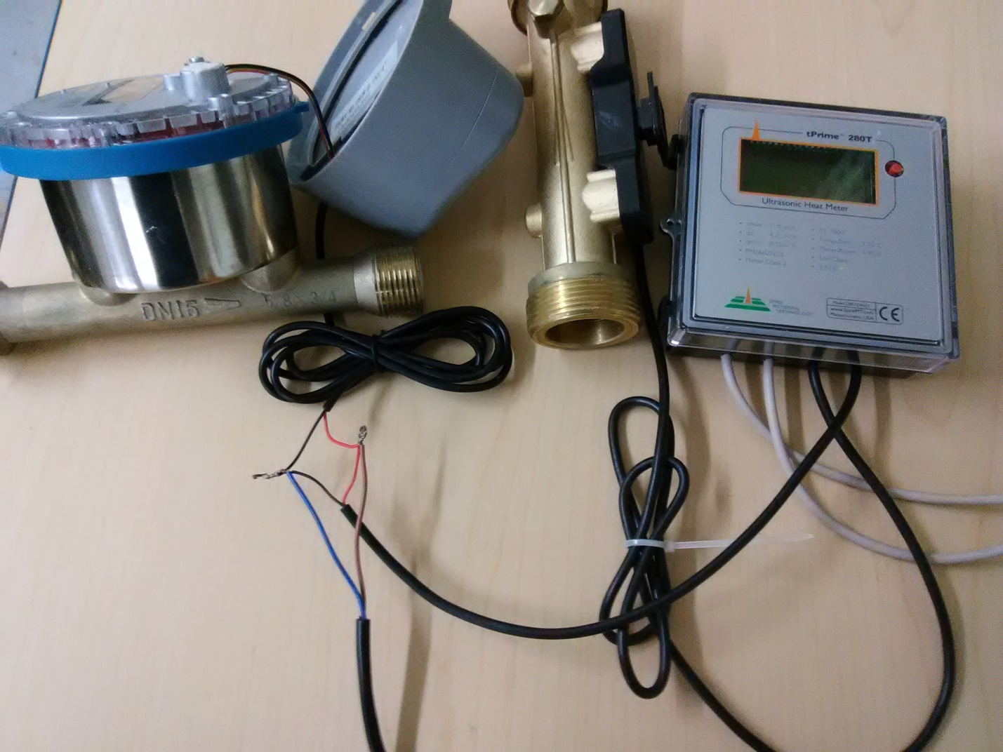

**Detailed wiring connection to meters**

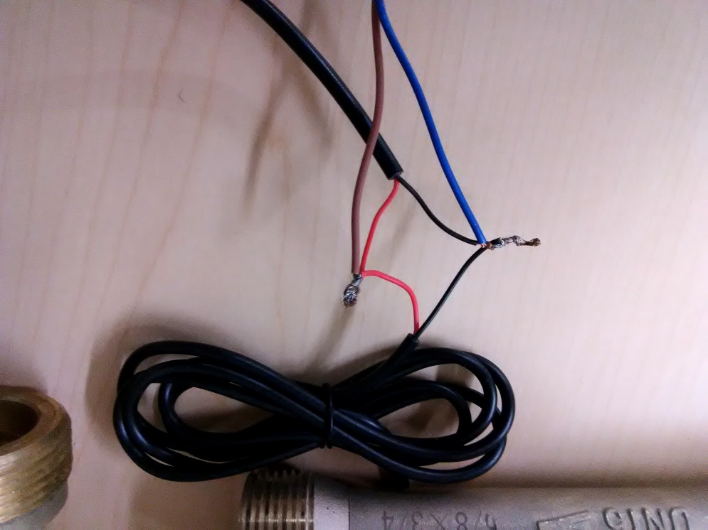

**Concentrator**

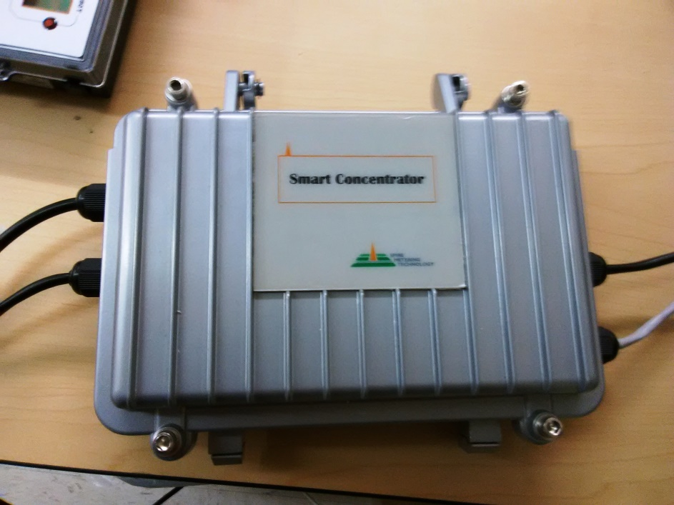

AC power in COM port to PC Mbus I/O from meters

M Bus Sheet V1.6 showing meters from COM2

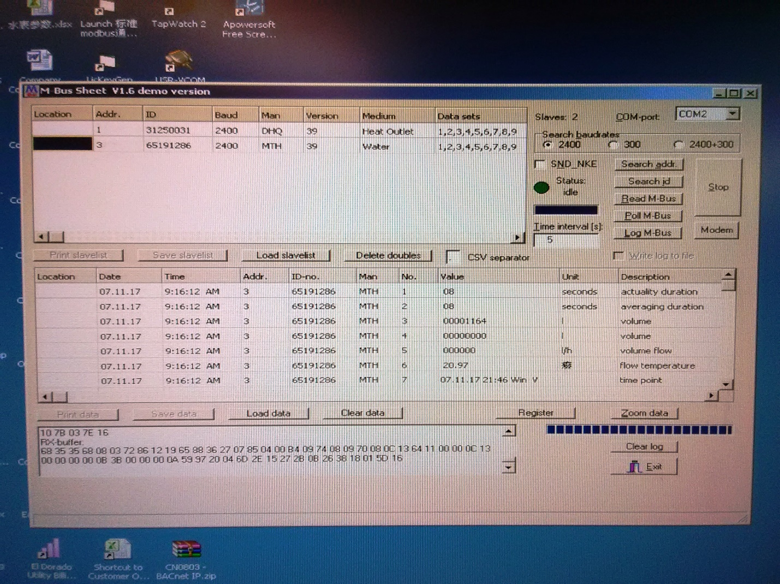

**Chart to determine what 280 meter you have**

|  |  |  |
| --- | --- | --- |
| Type | No. of Wires | Colors |
| **Encoder** | 3 | Black, Red, Yellow |
| **MBus** | 2 | Red, Black |
| **Pulse (w/o battery)** | 2 | Yellow, White |
| **Pulse (w/ battery)** | 4 | Yellow, White, Red, Black |
| **Modbus** | 4 | Red, Black, Blue, Yellow |
| **Modbus + 4-20mA** | 6 | Red, Orange, White, Black, Yellow, Green |

Encoder (3 wires)

Black Gnd

Red Vdc

Yellow D+

MBus (2 wires)

Red MBus +

Black MBus –

**Pulse (w/o battery)**  (2 wires)

Yellow B-

White A+

**Pulse (w/ battery)**  (4 wires)

Red Vdc

Black GND

Yellow B-

White A+

Modbus (4 wires)

Red Vdc

Black GND

Blue A+

Yellow B-

Modbus + 4-20ma (6 wires)

Red Vdc

Orange Ao+

White Ao-

Black GND

Yellow 485B

Green 485A